**Marketing and Consumer Behaviour for the Aviation Industry**

**2023-2024**

**STUDENT ID:**

**STUDENT NAME:**

***Executive Summary***

This report is focused on highlighting the SMART objectives of British Airways to successfully increase the sales of online tickets by around 30% within a year or more, targeting various aged customers from 25 to 40 in the aviation domain of the UK. The report further also outlines an integrated campaign of marketing with the use of email marketing, social media, and SEO to successfully achieve this particular goal and hence highlights the sustainability commitment of the company. In this report, the timeline, and proposed budget/costing of British Airways are shown depending on the SMART objectives and IMC policy that can bring about the result of a 30% increase in e-ticketing sales during peak hours and retention of valuable customers.

**Table of Contents**

Introduction 4

Overview of the Aviation Organization-British airways 4

Integrated marketing campaign (IMC) 7

IMC SMART objective 7

Target audience 9

IMC methods 11

Timeline 14

Costing 15

Return on investment (ROI) 16

Conclusion 17

References 18

# Introduction

An i***ntegrated marketing campaign*** abbreviated as IMC is an ***effective marketing tactic*** to provide service to targeted customer groups. The main goals of the business are to raise ***brand awareness, brand identity*** or ***better brand visibility*** by reinforcing of messages of a brand to a targeted audience (Das, 2021). The current report gives a glimpse of IMC-based smart objectives that are framed by British Airways, a UK-based aviation company to meet customers' needs in the market.

***Maximising e-ticketing*** or ***online ticketing sales*** during peak times is a key ***SMART objective*** for British Airways to gain customer loyalty and brand equity that strengthens the brand reputation for the aviation enterprise of British Airways Group. This study also gives an account of IMC methods that are incorporated by the British Airways group to meet its SMART objectives. ***Timeline, cost for budget plan*** followed by an account of ***“Return on investment”(ROI)*** also presented in this report.

# Overview of the Aviation Organization-British airways

**Web site:**<https://www.britishairways.com/travel/home/public/en_in/?Brand=Y&DM1_Channel=PPC&DM1_Mkt=IN&DM1_Campaign=PS_APMEA_IN_GGA_PPCAO_BAF_EN_MBR&SEO=N&DM1_Keyword=british%20airways&gad_source=1&gclid=CjwKCAjw8diwBhAbEiwA7i_sJeRgVKkKJ4RIQxM09ZbxXGIeI8NcmDAciH0JplTTdEYELVoCJZ-DbRoC3j8QAvD_BwE&gclsrc=aw.ds>

**Social media:**<https://www.instagram.com/british_airways/>

British Airways, a leading premium airline service provider operates access to ***80 countries with more than 200 destinations*** around the globe. ***Sean Doyle*** is currently serving as ***CEO of British Airways Group*** (British airways, 2024). ***20.8 billion Assets*** have been acquainted by British Airways Group by the end of 2022. ***Embracing digital technology*** and ***Customer-focused business initiatives*** is the reason behind the success of British Airways Group (Cozmuta, 2024). British Airways is a flag-based airline carrier in the UK with headquarters in London, England.

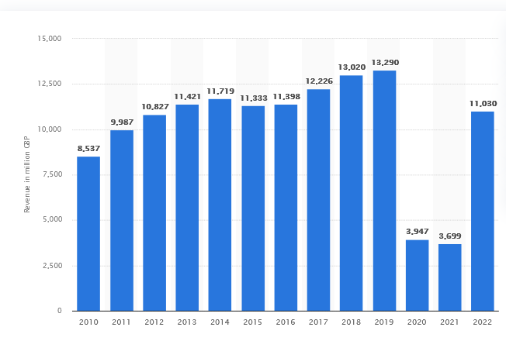

**Figure1: Forecast of Earned revenue for British Airways group**

(Source: Statista, 2024)

British Airways generated ***11 billion*** in ***revenue*** by the end of 2022 by delivering a seamless customer experience and satisfying customers' needs in the aviation segment. Being a prestigious and renowned aviation entity, looking into customers' amenities, comfort and delivery of premium services to customers is the key motto for aviation company British Airways. Since its inception in 1974 by the joint merger of ***“BEA” (British European Airways)***and***“BOAC” ( British Overseas Airways Corporation)*** meeting customers' needs and satisfying them is core to the company’s DNA for British Airways.

Being a renowned brand in the aviation domain, British Airways takes a pledge to lower its environmental carbon footprint to meet the needs of environmentally conscious customers. The opinion of Moore & Taylor (2021) reveals that making a fuel-efficient or effective aircraft, lowering the environmental carbon footprint of aviation and delivering premium quality customer service by focusing on quality or amenities are given prior stress by the aviation sector of the British Airways group. The key USP (unique selling proposition) of British Airways lies in its unique offering of services to its targeted customer segments in terms of luxurious experiences or amenities.

It offers premium quality services across six continents by dint of its unique or extensive global network. A rich heritage in the aviation domain brings success to its business due to its reliability, commitment, safety and value-added services. As per the views of Smith (2024), the loyalty program offered by British Airways keeps employees engaged and helps to gain customers' loyalty or equity for the brand. As per the views of Hamawandy et al., (2021) the innovative and environmentally sustainable initiative helps British Airways to meet its customers' expectations. Moreover, it helps to gain success in a market that is fiercely competitive with its top competitors including ***Virgin Atlantic, Delta Airlines, Emirates, Qatar Airways*** and ***Lufthansa Group.*** Leveraging technology and embracing the use of marketing campaigns helps British Airways to stay ahead in the market to compete with its key market competitors.

# Integrated marketing campaign (IMC)

An integrated marketing campaign abbreviated as IMC is a cross-channel marketing tactic or mechanism that utilises numerous channels for promotion including SEO operation, email marketing and social media-based operation of marketing to attract its targeted customer base. The main aim of an integrated market campaign is to judicious usage of channels to reach potential targeted customer groups to retain customers (AYTEKİN, 2024). It helps airlines capture customers by satisfying them and making the consolidation or expansion of airline operations seamless. Staying ahead in the fiercely competitive market against key competitors of Virgin Atlantic, Delta Airlines, Emirates, Qatar Airways and Lufthansa Group is a tedious task for British Airways. Moreover, it needs the usage of an integrated marketing campaign (IMC) to stay ahead in the forefront of the aviation sector. Maximising e-ticketing or online ticketing sales requires the usage of email marketing, social media marketing and SEO to reach potential customers between 25 and 40 years of age within the UK ***[Refer to appendix 1].***

# IMC SMART objective

British Airways aims to maximise its online ticketing or e-ticket sales by 30% in the next year among its potential customer segment between 25 and 40 in the UK aviation domain. Creating an ***integrated marketing campaign*** (social media, email marketing and SEO) to retain its targeted customer group helps British airlines attain a hold in market position or better market consolidation (Ellibeş& Candan, 2021). Pledge to adopt the ***Carbon Zero Initiative*** to meet sustainability targets at ***discounted e-ticketing fares*** during peak times helps to meet the company’s objective for profitability and market penetration in the fierce aviation domain (Zheng et al., 2020).

| Targets for British airlines in aviation to meet the SMART objectives (specific, attainable, measurable, time-bound and relevant):  Maximise the e-ticketing sales by 30% during peak hours to retain customers by following an IMC (Integrated marketing campaign) including social media, email marketing and SEO | |
| --- | --- |
| ***Specific*** | * Objectives in terms of IMC (Integrated marketing campaign) are smart as they describe the specific age of the targeted customer group lying between 25 and 40 * The UK is the target market for British Airways to gain a rise of up to 30% raise of ticketing sales |
| ***Measurable*** | * Integrated campaigns for marketing like social media, email marketing and SEO help to keep track of customers' information inclined toward aviation services provided by British Airways Group * Analytics data are accessible from social media helping to track customers' data within the age bar |
| ***Attainable*** | * The approach of an integrated marketing campaign abbreviated as IMC helps to meet the attainable targets for British Airways in terms of raising online or e-ticketing sales across the UK * Delivery of tickets at a discounted price, online promotion or email campaign gives added advantages to British Airways |
| ***Relevant*** | * Relevant social media campaigns, pledging to lower carbon emissions by taking eco-initiatives help British Airlines to make business expansion and consolidation seamless |
| ***Time-bound*** | * Gaining the desired outcome for the aviation of British Airlines requires an approximate time of 12 months or 1 year to translate its goals into reality |

**Table 1: IMC SMART objective For British Airways**

(Source: Self-created)

# Target audience

British Airlines put prior focus on its customer group ***between 25 and 40 age*** to raise the sales of its online or e-ticket. Satisfying customers and retaining them simultaneously is a herculean task for British Airways that requires prior market commitment and usage of market campaigns in an integrated way to gain momentum (Syeda, 2022). British Airways is required to follow the ***self-determination theory*** as enshrined by Richard Ryan and Edward Deci to meet customers' expectations and deliver them services that motivate them to go for luxurious services or e-ticket options given by the aviation company British Airways Group. The parameters (autonomy, relatedness and competence) as given by ***self-determination theory (SDT theory)*** followed by British Airways group help it to track customers' information and help to make a proper way to meet the needs of its target audience.

**Figure 2: SDT theory**

(Source: Self-created)

***Autonomy:*** Customers are more likely to be satisfied by offerings given by British Airways because they get lucrative discounts of up to 30% on peak times to their destination tours which give them the autonomy or support to go for British Airways without any choices. Moreover, it gives British Airways an edge to stay competitive or fierce market competitors from Virgin Atlantic, Delta Airlines, Emirates, Qatar Airways and Lufthansa Group (Kassem, Salama &Ganepola, 2022). Usage of market campaigns like social media-based marketing, SEO operation and email marketing gives an edge to British Airways to influence customer groups and connect with them emotionally to raise sales for e-ticketing sales in the aviation industry ***[Refer to appendix 2].***

***Competence:*** Meeting the need for a target customer group lying between 25 and 40 years old requires differentiating customers into certain groups based on their choices or requirements that give the competence to deliver proper service delivery to end customers by the British Airways group.

***Relatedness:*** British Airways make a plan to differentiate its customers according to their spending habits and capabilities to make the online rise of sales of ticketing services seamless. Customers or target audiences are of several types such as budget-conscious, family travellers; frequency-based travellers, international travellers coupled with leisure, and business travellers’ group (Cozmuta, 2024). Making a breakdown of its targeted customer segment based on these relatable factors helps British Airways to make the rise of its sales to attain the SMART objective to raise e-ticketing sales by the end of the year (Milestone, 2023). Differentiating customers between 25 and 40 based on this relatable outcome helps to sustain in the long go.

# IMC methods

One of the most important strategic approaches that is used by various businesses to ensure consistency in the efforts of their marketing across various channels is known as "***Integrated Marketing Communications (IMC)***” (Kitchen &Tourky, 2022). In the aviation industry context, 3 important IMC methods are known as email marketing, social media marketing, and “search engine optimization (SEO)”. Here, now let's delve into each of these methods and how they perfectly align with the provided SMART objectives.

***Social Media Marketing***: The marketing of social media mainly involves leveraging various platforms like Twitter, Instagram, Facebook, and LinkedIn to successfully engage with various potential customers (Eagle et al. 2020). The chosen company British Airways could easily use social media to successfully create their targeted campaigns that are mainly aimed at individuals aged from 25 to 40 in the aviation domain of the UK. With the analysis of various insights and data that have been provided by all these platforms, this company could easily tailor their respective content to resonate with this particular demographic (Al-Azzam et al. 2020).

British Airways, could also share its enticing videos as well as visuals showcasing its promotions, services, and destinations that mainly appeal to various young adults (Syeda, 2022). They could further also run some interactive campaigns like quizzes, polls, and contests to successfully encourage engagement as well as foster a community sense among their target audience. For example, Emirates Airlines is a very well-known company for its effective social media marketing use (Syeda, 2022). They post high-quality and very impressive content regularly that highlights their luxurious destinations, amenities, and experiences of travel, effectively capturing the target audience's attention.

***Email Marketing***

Another important strategy is “Email marketing” which remains a very powerful tool for reaching out to all the customers directly. The chosen company British Airways could easily build a potential customer database within the specified group of age and hence could send them personalized emails with the promotion of their special offers and e-ticket sales (Marinchak et al. 2023). With the segmentation of the list of their email based on various important factors like past purchase behaviour, demographics, and interests, the company British Airways could easily deliver relevant content that strongly resonates with each of their recipients. They could further also incorporate personalized recommendations as well as dynamic content to enhance the effectiveness of the campaign.

For example, another famous airline company “Southwest Airlines” is mainly renowned for its successful campaigns of email marketing (Marinchak et al. 2023). They mainly send out regular newsletters that feature exclusive deals, travel tips, and personalized recommendations that are mainly based on past interactions of customers with the brand.

***Search Engine Optimization (SEO)***

Furthermore, SEO mainly involves the optimization of the content of a website as well as its structure to successfully improve its visibility on the pages of search engine results. The chosen company British Airways could also optimize its official website for some relevant keywords related to air travel as well as online ticketing within the aviation industry of the UK (Syeda, 2022). With the conduction of thorough research of keywords as well as optimization of the meta tags of their website, content, and headings, the company British Airways could easily improve their search engine ranking like Google (Syeda, 2022). This will further also increase the visibility of their organic and hence could easily drive more qualified website traffic for their customers, ultimately resulting in increased sales of e-tickets.

For example, another famous airline company "Ryanair" mainly excels in SEO (Eagle et al. 2020). They have further also made a significant and heavy investment in the optimization of their website for various relevant keywords, resulting in a very important increase in online bookings and organic traffic.

***Integration:***

In order to successfully meet their SMART objective of increasing e-ticket sales as well as online ticketing by around 30% among their targeted demographic, the company British Airways is also required to integrate all these three methods of IMC seamlessly (Syeda, 2022). Just for example, they could easily use social media for the promotion of discounts on e-tickets as well as exclusive deals, direct some of their interested users to their official website with the medium of email campaigns, and hence could also ensure that their website is successfully optimized for relevant queries search to capture organic traffic (Al-Azzam et al. 2024). Just with the help of synchronizing all these important efforts as well as maintaining consistency in branding across all important channels as well as messaging, the company British Airways could very effectively engage their respective target audience and hence could drive conversions, ultimately also achieving all their SMART objective.

Overall, with a strategy employment of email marketing, social media marketing, and SEO, British Airways could further create a very robust integration of marketing campaign that would not only help target but could also resonate with their desired demographic, resulting in a very increased sales of e-ticket as well as market consolidation.

# Timeline

|  |  |  |  |  |  |  |  |  |  |  |  |  |
| --- | --- | --- | --- | --- | --- | --- | --- | --- | --- | --- | --- | --- |
| **Activity** | **Months** | | | | | | | | | | | |
|  | **1** | **2** | **3** | **4** | **5** | **6** | **7** | **8** | **9** | **10** | **11** | **12** |
| Identify the target audience, peak hours, and strategy of the IMC plan |  |  |  |  |  |  |  |  |  |  |  |  |
| Developing sources, applications, and techniques |  |  |  |  |  |  |  |  |  |  |  |  |
| Utilizing the network of the company for further marketing |  |  |  |  |  |  |  |  |  |  |  |  |
| Launch the IMC campaign |  |  |  |  |  |  |  |  |  |  |  |  |
| Advertising campaigns by social media and other sources |  |  |  |  |  |  |  |  |  |  |  |  |
| Monitoring the reach and gathering feedback |  |  |  |  |  |  |  |  |  |  |  |  |

**Table 1: Timeline**

(Source: Self-Created)

# Costing

|  |  |  |  |
| --- | --- | --- | --- |
| **Type of Costs** | **Activity or category** | **Estimate Cost ($)** | **Possible Sources of Income** |
| **One Time Costs** | Initial Setup and Integration | 20,000 | * Establishing analytical, optimization tools, and advertising platforms * Improving users` mode and making booking more seamless * Creation of the artwork, ads, and copy of advertising campaigns. * Conducting Email campaigns * The budget will focus on search engines, social media, and travel websites * Advertising budget, working with influencers, content design |
| Website and Mobile App Optimization | 150,000 |
| Creative and Content Production | 60,000 |
| **Recurring costs** | Email Marketing | 40,000 |
| Digital Marketing | 200,000 |
| Social Media Marketing | 100,000 |
| Analytics and Optimization Tools | 30,000 |
| Agency Fees | 150,000 |
| **Total Budget** | | 750,000 | |

**Table 2: Budget Plan**

(Source: Self-Created)

The one-time spending, viewed as an operational investment is instrumental in the creation of a strong online booking environment and resourceful marketing asset for the captivation of the targeted audience. This repeated expenditure is essential to ensure communication with the audience, keep the target audience consistently engaged, and optimize the campaigns based on the actual data performance (Cozmuta, 2024). They constitute one of the main contributors to the attainment of the SMART objective which is achieving high e-ticketing sales through adverts on different channels. Through the injection of one-time and routine financing, British Airways will conform the IMC strategy to the preferences and behaviour of the desirable segment, and reaching the goal - 30% of e-ticket sales during peak hours is possible and the customer base will be increased.

# Return on investment (ROI)

The Return on Investment (ROI) for this IMC campaign will help to meet the SMART objective of maximizing e-ticketing sales by 30 percent during peak hours. This ROI can be measured as follows:

* ***Tracking e-ticketing sales during peak hours:*** This tracks the increase in sales volume and revenue from online appointments by peak hours to the previous period.
* ***Conversion Rate Optimization:***Analyse the call conversion rate of people going to the website and those going through the app during peak hours who perform e-ticket bookings (Bernier, 2022). This rate should be considered as one of the optimization goals.
* ***Customer Retention:*** Gauging the repeat customers and calculating booking rates over time can be around the campaign's effectiveness.
* ***Cost per Acquisition:*** Compute the wireless of a new customer's acquisition and find the average value of the customer lifetime for that campaign.
* ***Overall Revenue Growth:*** Determine the total e-ticket revenue obtained during apex hours including all the costs involved, and then the net profit and the ROI exchange.

Using this performance device of evaluating these metrics periodically and adjusting the campaigns according to the data insights (Abdullah, & Ahmad, 2021). These methods will then allow British Airways to give themselves a confident investment in IMC policy that can bring about the result of a 30% increase in e-ticketing sales during peak hours and retention of valuable customers.

# Conclusion

The chosen organization, British Airways is one of the most important players in the industry of aviation. This organization mainly aims to enhance the sales of its online ticketing by 30% within the upcoming years among various customers aged from 25 to 40 in the UK. This particular SMART objective is perfectly perfectly-aligned with the focus of the company on the satisfaction of their customers as well as consolidation of the market. With the implementation of an "integrated marketing campaign (IMC)" involving email marketing, social media, and SEO, the company British Airways mainly seeks to engage with its target audience very effectively and hence could strengthen the position of its market. In addition, the commitment of the company to sustainability with the help of various initiatives like the "Carbon Zero Pledge" mainly adds value to all its offerings and hence also contributes to the goals of its profitability. With a major focus on measurable, specific, relevant, attainable, and time-bound targets, this company mainly aims to meet all the evolving requirements of its customers while also driving success and growth in the competitive airline sector.

# References

Abdullah, A., & Ahmad, J. (2021). Role of public relations in managing crises through social media platforms: A case of two airlines. *SEARCH Journal of Media and Communication Research (SEARCH)*, 183. https://fslmjournals.taylors.edu.my/wp-content/uploads/SEARCH/SEARCH-2021-Special-Issue-ICEMC2021/SEARCH-2021-Special-Issue-ICEMC2021.pdf#page=192

Al-Azzam, A. F. M., Alserhan, A. F., & Al-Assaf, K. T. (2024). Examining the Influence of Integrated Marketing Communications on Firm Performance: An Empirical Study. *Journal of System and Management Sciences*, *14*(3), 418-436. <https://www.aasmr.org/jsms/Vol14/No.3/Vol.14.No.3.24.pdf>

AYTEKİN, N. (2024). BRITISH AIRWAYS’TEN NIKE’A: REKLAMDA YÜZ İMGESİ VE BİR DÜNYA YAPMAK. *BeykozAkademiDergisi*, (SINIRSIZ: DÜNYA YAPMAK & ÖTESİ”), 143-166. https://doi.org/10.14514/beykozad.1368078

Bernier, L. (2022). The 2008 economic crisis and the rebirth of public enterprises. *The Economy of the Collective Interest: 75 years of scientific research*, 281. https://www.ciriec.uliege.be/wp-content/uploads/2022/06/CSS5BOOK-ENepdf.pdf#page=296

British airways (2024*) country choice* https://www.britishairways.com/travel/country_choice/public/en_in/?source=MNVLNG

Cozmuta, A. (2024). Selling ‘The World’s Favourite Airline’: British Airways’ privatization and the motives behind it. *Business History*, *66*(1), 181-200. https://eprints.gla.ac.uk/240788/1/240788.pdf

Cozmuta, A. (2024). Selling ‘The World’s Favourite Airline’: British Airways’ privatisation and the motives behind it. *Business History*, *66*(1), 181-200. https://doi.org/10.1080/00076791.2021.1926991

Das, S. (2021). A systematic study of integrated marketing communication and content management system for millennial consumers. In *Innovations in digital branding and content marketing* (pp. 91-112). IGI Global. DOI: 10.4018/978-1-7998-4420-4.ch005

Eagle, L., Czarnecka, B., Dahl, S., & Lloyd, J. (2020). *Marketing communications*. Routledge. Doi: 10.3390/su122310209.

economist.com, (2019) British Airways’ profits may not fly high much longer. <https://www.economist.com/business/2019/10/19/british-airways-profits-may-not-fly-high-much-longer>

Ellibeş, E., & Candan, G. (2021). Financial performance evaluation of airline companies with fuzzy AHP and grey relational analysis methods. *Ekoist: Journal of Econometrics and Statistics*, (34), 37-56. https://dergipark.org.tr/en/download/article-file/1710030

Hamawandy, N. M., Ali, R., Bewani, H. A. W. A., bdulmajeed Jamil, D., Rahman, S. K., & Othman, B. J. (2021). The financial Impacts of (COVID-19) on financial reporting quality Airlines Companies: British Airlines. *The journal of contemporary issues in business and government*, *27*(2), 5264-5271. https://cibgp.com/au/index.php/1323-6903/article/view/1429

Kassem, R., Salama, A., &Ganepola, C. N. (2022). CSR, credibility, employees' rights and legitimacy during a crisis: a critical analysis of British Airways, WizAir and EasyJet cases. *Employee Relations: The International Journal*, *45*(1), 1-20. https://oro.open.ac.uk/83988/1/83988.pdf

Kitchen, P. J., &Tourky, M. E. (2022). *Integrated marketing communications: a global brand-driven approach*. Springer Nature. <https://books.google.com/books?hl=en&lr=&id=YJtXEAAAQBAJ&oi=fnd&pg=PR6&dq=Integrated+Marketing+Communications+(IMC),+British+Airways+&ots=Y1leh5Rm1v&sig=KP3vabPgL2wOvfDBLCEQ1WidSaY>

Marinchak, C. L. M., &DeIuliis, S. M. (2023). *Corporate Communication and Integrated Marketing Communication: Audience Beyond Stakeholders in a Technological Age*. Rowman & Littlefield. <https://doi.org/10.4324/9780429057731>

Moore, S., & Taylor, P. (2021). Class reimagined? Intersectionality and industrial action–The British Airways dispute of 2009–2011. *Sociology*, *55*(3), 582-599. <http://gala.gre.ac.uk/id/eprint/30554/7/30554%20MOORE_Class_Reimagined_Intersectionality_and_Industrial_Action_2020.pdf>

Smith, L. C. (2024). ‘Like aid given by a mother to her young’: The British Overseas Airways Corporation (BOAC) and the marketing of economic development 1948–1965. *Business History*, 1-26. https://doi.org/10.1080/00076791.2024.2319341

Statista (2024) *british-airways-worldwide-revenues-*<https://www.statista.com/statistics/264296/british-airways-worldwide-revenues-since-2006/>

statista.com, (2024) Annual net profit of British Airways plc from 2011 to 2022. <https://www.statista.com/statistics/1007530/net-profit-british-airways-plc/>

Syeda, M. S. (2022). A Review Power of Integrated Marketing Communications. *Message from the Editor-in-Chief*. DOI:10.33168/JSMS.2024.0324 https://ijmir.org/doc/archive/special_issue/2022%20Apr'%20Special%20Issue.pdf#page=216

Zheng, S., Fu, X., Jiang, C., & Ge, Y. E. (2020). Airline investments in exclusive airport facilities: Timing decisions under demand ambiguity. *Transportation Research Part B: Methodological*, *139*, 343-363. https://doi.org/10.1016/j.trb.2020.05.004

# Appendices

## Appendix 1: Annual net profit for British Airways group in fiscal year 2022

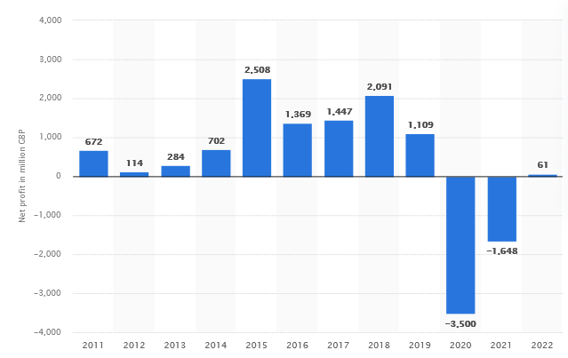

(Source: statista.com, 2024)

## Appendix 2: Data on British airways

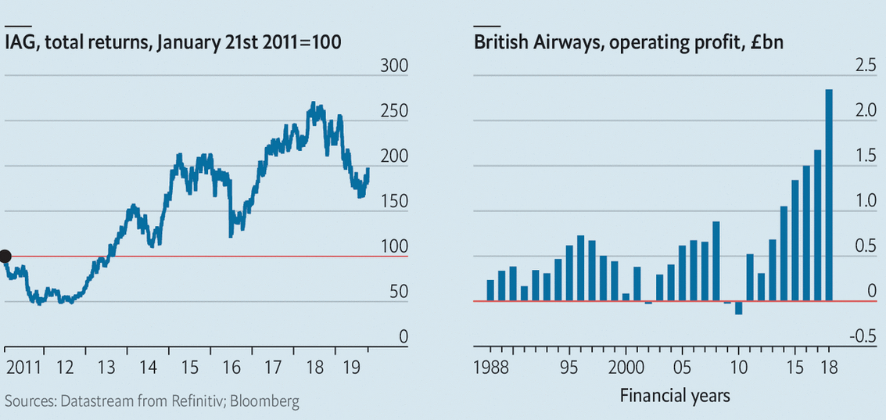

(Source: economist.com, 2019)